T.E.A.C.H. Elementary
To Encourage and Challenge Homeschoolers
www.teachcleburne.com
3rd Grade-Neely Vasquez
3rdgrade.teachcleburne@gmail.com
817-240-3352

MATH
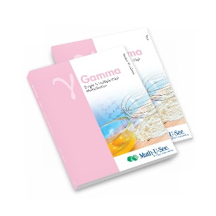
MATH-U-SEE GAMMA STUDENT PACK (contains student workbook and Gamma tests) SKU#: 1031
Gamma Student Pack (demmelearning.com)

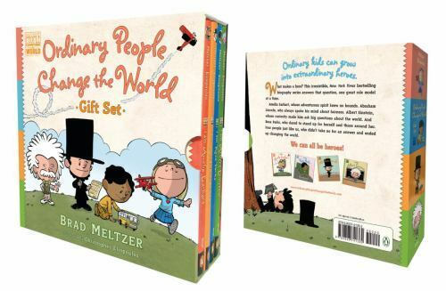
SOCIAL STUDIES: HISTORICAL FIGURES
Books to Purchase:
Ordinary People Change the World Gift Set by Brad Meltzer
(Contains 4 books-Can be found on Amazon)

