T.E.A.C.H. Elementary
To Encourage and Challenge Homeschoolers
www.teachcleburne.com
3rd Grade-Neely Vasquez
3rdgrade.teachcleburne@gmail.com
817-240-3352

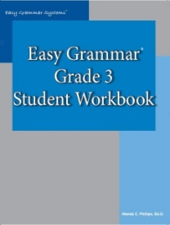
3rd Grade Language Arts

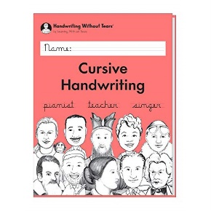
EASY GRAMMAR GRADE 3 STUDENT WORKBOOK-PRODUCT #482
https://www.easygrammar.com/easy-grammar---grade-3.html

LEARNING WITHOUT TEARS-CURSIVE HANDWRITING STUDENT WORKBOOK (FOUND ON AMAZON) https://www.amazon.com/Learning-Without-Tears-Handwriting-Workbook/dp/1939814480/ref=sr_1_5?dchild=1&keywords=cursive%2Bworkbook&qid=1592850339&sr=8-5&th=1

NOVELS TO PURCHASE:

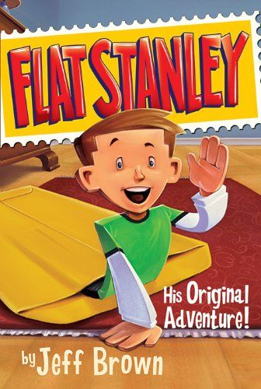
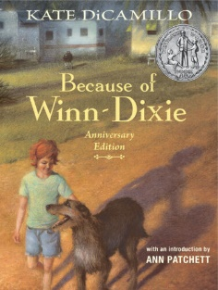
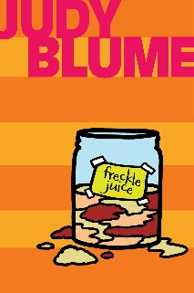
Flat Stanley: His Original Adventure by Jeff Brown
Because of Winn-Dixie by Kate DiCamillo
Freckle Juice by Judy Blume

