T.E.A.C.H. Cleburne
www.teachcleburne.com
Linda Chaplin
grade5teachcleburne2024@gmail.com
817-933-4755

(Do Not purchase e-books)

5th GRADE LANGUAGE ARTS
Easy Grammar Grade 5
https://www.easygrammar.com
Student Workbook Product #451 (print format)

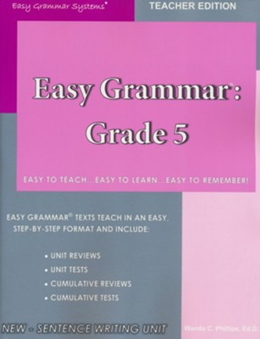

5th GRADE READING LIST
Copies may be new or used but hard copies are required for in class reading and discussion.
Where the Red Fern Grows by Wilson Rawls
Across Five Aprils by Irene Hunt
Wish by Barbara O’Connor
Hatchet by Jean Craighead George
Frindle by Andrew Clements

5th GRADE MATH
Math U See Epsilon
Student Pack (print format)
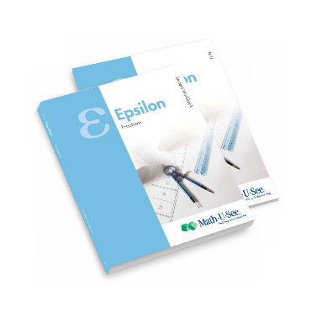
https://store.demmelearning.com/epsilon-student-pack.html

5TH GRADE SCIENCE
(print format)
R.E.A.L Science Odyssey Physics Level 1 Student Pages
REAL Science Odyssey - Physics Level One, Student Pages • Pandia Press

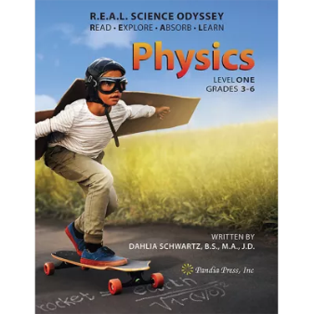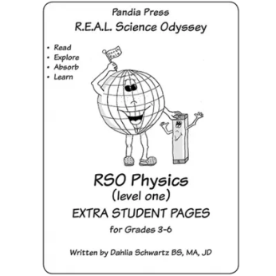
You will only need the student pages. The first image is the teacher book that student pages go with.

5th GRADE WORLD GEOGRAPHY
World Geography Grades 5-8, by Richard Rayburn
https://www.christianbook.com/world-geography-grades-8-3rd-edition/richard-rayburn/9780743937993/pd/937996
World Reference Maps & Forms
https://www.evan-moor.com/the-world-reference-maps-forms-grades-3-6-teacher-resource-print

