T.E.A.C.H. Elementary
To Encourage and Challenge Homeschoolers
www.teachcleburne.com

Shannon Dildy

First Grade

817-999-7281

1stgrade.teachcleburne@gmail.com

1st Grade Math
10:55-11:50 Tuesday/ Thursday

LIST BOOKS/SUPPLIES TO PURCHASE:

Math U See: https://store.demmelearning.com/math-u-see/general-math/alpha
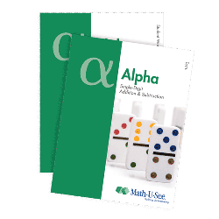
Math U See: Alpha Student Pack

1st Grade Science/Social Studies
12:40-2:25 Tuesday/ Thursday

LIST BOOKS/SUPPLIES TO PURCHASE:

Science: Building Blocks Study Notebook
Purchase from the teacher: $10.00

Social Studies: No textbook required

