T.E.A.C.H. Elementary
To Encourage and Challenge Homeschoolers
www.teachcleburne.com

Shannon Dildy

First Grade

817-999-7281

1stgrade.teachcleburne@gmail.com

1st Grade Language Arts
9:00-10:15 Tuesday/ Thursday

LIST BOOKS/SUPPLIES TO PURCHASE:
Logic of English Foundations: https://store.logicofenglish.com/collections/product-type-foundations

Foundations C Student Workbook - 2nd Edition

Foundations C Readers

Miles and Jax

Miles and Jax: Master Planner

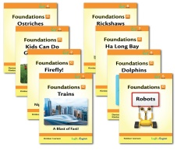
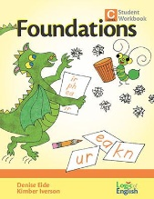
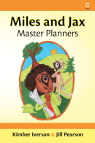

Foundations D Student Workbook
Foundations D Readers

